James Lind Alliance Priority Setting Partnership
Physical and Mental Health in Prison
Survey 1 – Community Easy Read Information

- If you were in prison, did you have any physical and mental health conditions when you were in prison?
- Do you have a family member or someone you care for who has been in prison (now or in the past) and had physical and mental health conditions while in prison?
- Do you work with people in prison who have physical and mental health conditions?

What would you like to see improved?

Complete this survey and tell us what would help.

You are being invited to take part in a consultation…

What is this project about?   | This survey has been written by researchers at the University of York.  We want to know what questions you think researchers should focus on.
Why are we doing this?   | We are trying to find out what research would help support people with physical and mental health conditions in prison.
Who can take part?   | Anyone with lived, family/carer or professional or experience of physical AND mental health problems in prison.  Examples of physical and mental health problems are:  - Physical:  - Asthma  - Diabetes  - Hypertension  - Obesity  - Chronic Obstructive Pulmonary Disease (COPD)  - Mental health:  - Anxiety  - Panic disorder  - Phobias  - Obsessive-compulsive disorder  - Post-traumatic stress disorder  - Depression
What is involved…
Do I have to take part?   | No. You do not have to take part.  If you say yes, you can change your mind and stop at any time. You do not have to tell us why.
What will happen if I say yes?   | All you need to do is answer a few short questions.  We want you to give us your research ideas.  Questions will be asked in English.
What might be good about taking part?  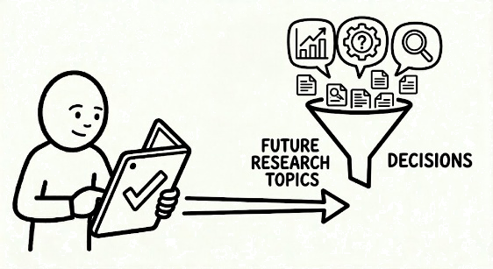 | Your voice is important to us. Your research ideas will help us to make future improvements.  As a way to thank people who take part, we will make a donation to charity at the end of the project. We will ask you to vote for a charity at the end of the survey.
What might be bad about taking part?   | It will take about five minutes of your time to complete. If you have any problems with the survey please email us at: jla-prison-health-project@york.ac.uk
The details…
What will happen to my information?   | Your information will be kept safe by the University of York. It will not contain your name or anything that could identify you.
I’d like to talk to someone…  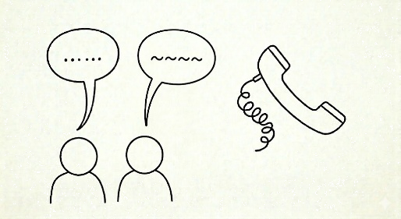 | If you would like to talk to someone about your physical or mental health, you can talk to your GP or call NHS 111.
What will the survey ask?   | The survey will ask:  What experience do you have:  - Lived experience  - Family/carer experience  - Professional  - Both professional and lived experience  If relevant, what physical and mental health conditions you, or your family member, experienced while in custody.  If relevant, what your professional role is.  Thinking about your experiences…  What questions do you think future research should ask, to better support people in prison with both physical and mental health conditions?  We will also ask your gender, age and ethnicity. This is so that we understand who has answered the survey.
What happens after the survey is finished?   | Once we have summarised the results, the findings from survey will be shared on the project webpages:  - https://www.jla.nihr.ac.uk/physical-and-mental-health-prisons  - https://www.york.ac.uk/health-sciences/research/mental-health/projects/physical-mental-health-prisons/

